MP4 Steganography

Clint Bhola
cbhola@hawk.iit.edu
Mossa Hana
mhana1@hawk.iit.edu

ABSTRACT
This paper seeks to describe how TrueCrypt, a popular tool for encrypting file systems, can also work with file systems inside encrypted container files such as those found in MPEG-4 files. Through this method users can hide sensitive files without raising suspicions about its hidden content.
It also examines another tool called OpenPuff which claims to be “an advanced watermarking and Steganography, or data hiding, program capable of storing up to 256MB of encrypted data using an invisible copyright mark in pictures, video, audio, and flash files.” It will attempt to analyze these claims and determine their authenticity.
Categories and Subject Descriptors
D.3.3 [Programming Languages]: Language Constructs and Features – abstract data types, control structures.
General Terms
Algorithms, Documentation, Performance, Design, Reliability, Experimentation, Security, Theory, Verification.
Keywords
Truecrypt, MPEG-4, Encryption, Containers, Steganography, MP4, Volumes, OpenPuff, Hiding, Carriers.

INTRODUCTION
The advantage of steganography, over cryptography alone, is that messages do not attract attention to themselves. Plainly visible encrypted messages — no matter how unbreakable — will arouse suspicion, and may in themselves be incriminating in countries where encryption is illegal. Therefore, whereas cryptography protects the contents of a message, steganography can be said to protect both messages and communicating parties.
Crossing borders with sensitive information can be difficult in areas where information is tightly controlled. People have always looked for ways to encrypt information and hide it with-in other content - a form of encrypted steganography. Advances in technology have allowed for more secure and subtle methods of steganography. Using Truecrypt, an open source file encryption software, files can be hidden on volumes as well as be placed with-in containers such as those found in video files.
Ordinarily, anyone trying to open an encrypted Truecrypt volume would receive an error message, making the encryption obvious. To create a secure and encrypted volume that would raise no suspicion by a user, the secret information is encrypted and placed inside of any MPEG-4 (MP4) video in a hidden TrueCrypt volume; the video plays even after the hidden volume is placed inside its container.

BASIC CONCEPTS
TrueCrypt offers a simple form of steganography, in fact, construction of such a hybrid steganographic file is just an application of a common discipline in esoteric computing: It’s all about generating a file that is valid in multiple formats. In this case, TrueCrypt container files are also usable in some other common formats i.e. QuickTime or MP4 formats.
Programs like OpenPuff on the other hand tend to abuse common file format flukes. For example most file formats like MP4 start with a header that describes the data contained in the file, as well as providing byte offsets to its data chunks. Software specific to the displayed file extension will often disregards data placed beyond the file header offsets; data can be appended to these outer limits without destroying the file or making it unusable.

The TrueCrypt format
Figure 1 shows how the TrueCrypt container file is organized. The structure is not easily detectable using programs such as a hex editors'. All headers are encrypted and can only be decrypted with the proper key. This feature is implemented with-in the design. A stated goal of TrueCrypt states that containers shall look like random garbage and thus must not have any unencrypted headers in them. However, the location and size of the headers is well-defined and documented: The main header of the outer volume is located at offset 0 in the file and can be up to 65,535 bytes in size (of which usually just a few hundred are used). This means that a hybrid file cannot be created with a format that requires header data within the first 64k bytes, without sacrificing the volume header. This can be over looked since the hidden volume header, located at offsets 65,536 to 131,072, is sufficient to mount a hidden volume. Thus the first 64k bytes of a TrueCrypt file can be over written with anything, while still maintaining access to the hidden volume. The outer volume will be lost, but this is an acceptable trade-off, since the hidden volume can be made as large as possible when creating the container, The only space that will be lost is the file system overhead of the outer volume, which is typically less than 5 percent of the volume size.
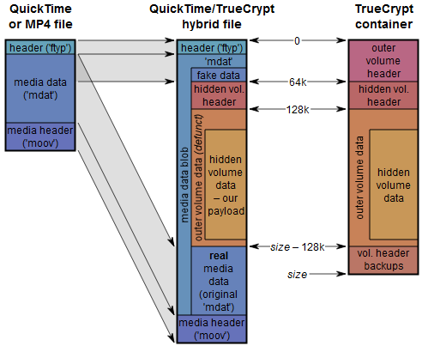
Figure 1 Showing the structure of the Truecrypt Container
Source: keyj.emphy.de/real-steganography-with-truecrypt/
In addition to the two volume headers, there are backups of both starting at 128k before the end of the file. Since the data is appended to allow the TrueCrypt file to store the data on the video file, this data will be lost; they will be present but TrueCrypt won’t find them. However, this does not present a major issue, since TrueCrypt will only resort to the backups if the main headers are damaged.

A hybrid file can be created with a hidden TrueCrypt volume out of an existing TrueCrypt container file by appending data and rewriting the first 64k of the file at will. A disguise file must be created now to meet these requirements. In particular, a way must be created to make empty space between the 64k mark and the end of the TrueCrypt volume that is ignored by applications reading the file in the format that it claims to be.

The QuickTime format

MPEG-4 Structure
The QuickTime format and the MPEG-4 file format (ISO 14496-14), which is based on it, consists of so-called atoms. These are chunks of data consisting of a 4-byte length value, a 4-byte ASCII type identifier and an arbitrary amount of payload that may be composed of sub-atoms again.

Figure 2 Showing the structure of an MP4 container
Source: www.maximumpc.com/article/features/white_paper_media_container_file_formats
There are three top-level atoms that are required in every proper QuickTime or MP4 file: The main file header (atom ID ‘ftyp’), which is just a few bytes; the media header (movie header, atom ID ‘moov’), which is in the range from a few kilobytes to a few megabytes; and finally the main media data (atom ID ‘mdat’). Regarding the file layout, the only restriction enforced by the file format specification is that the ftyp atom must start at the beginning of the file, all other atoms may be reordered at will. In particular, it is not required that moov (the media header) precedes mdat (the media data).

There are some additional atom types that are common, but are not required to make a file playable; these can be removed without risk of damage. The most prominent of these is ‘free‘: Such atoms are just placeholders and don’t contain any useful data. These can be thought of as the QuickTime equivalent of comments.

One interesting thing that can be noted is that mdat doesn’t have any proper enforced structure. From the file format’s point of view, mdat is just a big blob of data that happens to contain media samples (i.e. audio and video frames). Where these samples can be found is specified in so-called chunk offset tables (atom ID ‘stco‘) inside the moov atom. These tables contain file offsets for each chunk of samples of the movie. All parts of the file that are inside mdat but are not referenced by the stcos are ignored by media players and are usable for steganographic exploits.

Creating a QuickTime/TrueCrypt hybrid
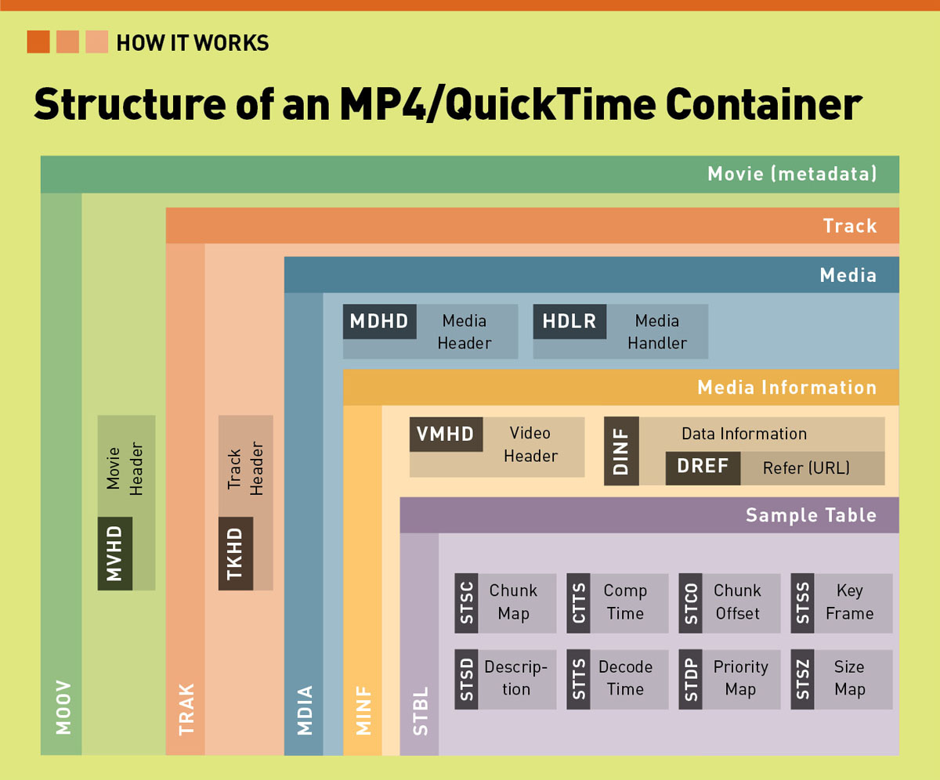
All MOV and MP4 files follow one of two different structures: The most common one is simply ftyp–moov–mdia, sometimes with a free at the end containing version information about the tool used to generate the file. The other common pattern is ftyp–mdat–moov, often with a very small 8-byte free before mdat as a placeholder for 64-bit offsets should the file grow above 4 GiB. This is a very useful layout for stenographic purposes: this can be easily counterfeited and still maintain the illusion of a perfectly legitimate QuickTime file. This is achieved by putting the real mdat right after the end of the TrueCrypt volume, followed by the moov header. A new mdat that spans both the TrueCrypt volume and the real media data is generated. Since a change is made in the file offsets of the media samples in this process, the chunk-offset tables have to be adjusted. For maximum credibility, the first kilobytes of the original mdat are copied to the front of the file. This way, the file looks innocuous even when viewed in a hex editor – for example, if the file was encoded with x264, the encoder’s SEI message is still visible.

Adding and extracting data on the hybrid TrueCrypt Volume.
After the creation and subsequent encryption of the Hybrid TrueCrypt volume, an implementation of TCStego through a python script is used to merge the carrier file (Org_video.mp4) and the TrueCrypt container (Crypt_Vol.mp4). The hybrid TrueCrypt container ‘Crypt_Vol.mp4’ now becomes a playable video file as well as a storage volume.
Using the TrueCrypt software the hybrid container file can be mounted as a removable drive using the password of the created hidden volume. Files can now be moved to and from the mounted hidden volume through the operating system.
(See UsrManX for detailed information on this process)

The OPENPUFF
According to the creators of OpenPuff, it “…is a handy application that allows you to hide data into encrypted files in order to send it to other users. The program can be useful for the users that want to send confidential information without being noticed.”

The program relies heavily on the open source library libObfuscate (see figures 3&4) to securely encrypt secret files using AES and 256+256bit encryption methods. The files are encrypted using a four-layer method:
Layer 1 - Modern multi-cryptography:
16 modern 256bit open-source cryptography encryption tools are used to encrypt the secret data.
Layer 2 - CSPRNG based scrambling:
Moov
[1% OpenPuff Data]
mvhd
trak
tkhd
edts
elst
mdia
mdhd
minf
stbl
stsd
stco
co64
stts
stss
stsc
stsz
trak
trak
..
mdat
[data]
[data]
[99% OpenPuff Encrypted Data]
In this layer is complete encrypted data is scrambled breaking up residue stream patterns that might be left over from layer 1. A random number generator ‘CSPRNG’ is added with a 256bit password that has been shuffled globally with random indexes.
Layer 3 - CSPRNG based whitening:
The incoming data is mixed with high levels of noise, taken from an independent CSPRNG seed that has been combined with hardware entropy.
Layer 4 - Adaptive non-linear encoding:
A Whitening transformation is now performed on the data and is then encoded using a non-linear function taking the original carrier bits as an input.

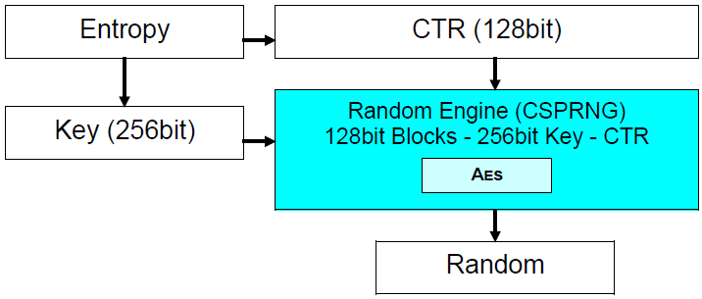
Figure 3 showing the Architecture of an AES seed for libObfuscate
Source: embeddedsw.net/libObfuscate_Cryptography_Home.html

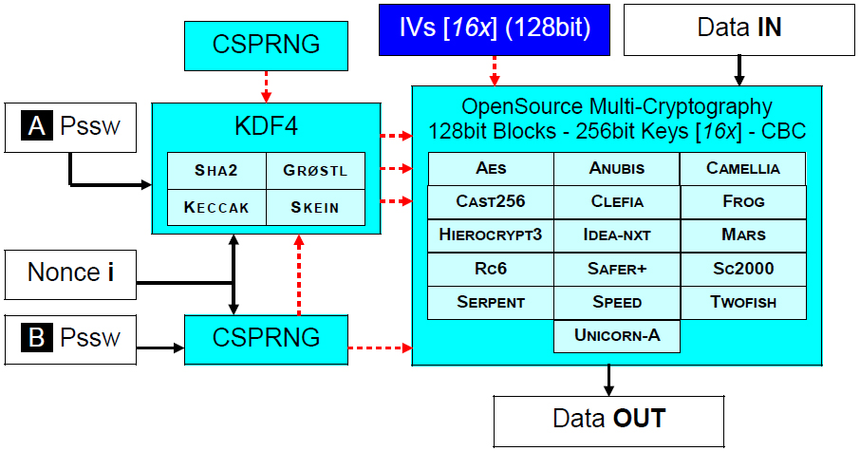
Figure 4 showing 256+256 bit - CBC - Segment Architecture
Source: embeddedsw.net/libObfuscate_Cryptography_Home.html

Covert data Hex-editor examination
Preliminary examination of OpenPuff encrypted .mp4 files using the hex-editor Win-Hex, showed discrepancies in the moov header and mdat atoms. The most noticeable differences in the original file (clean.mp4) vs. the OpenPuff (dirty.mp4) were in and after the end of the mdat atom.

Initial data from side by side comparisons of the clean and dirty .mp4 files allowed early conclusions to be drawn that OpenPuff hides files after the end of the file or close to the end of the file. It takes advantage of the fact that multi-media software read the header of the media files to determine their offsets and ignore any further attached data not specified in these offsets. Figure 4 depicts a rough abstract of a typical MP4 file and how OpenPuff exploits this hierarchy of atoms.
Figure 4 showing abstract atom hierarchy of a MP4 file.
Source: http://wiki.multimedia.cx/?title=QuickTime_container

Detection
There are only four ways to detect the presence of the hidden volume, all of which are unlikely to be checked even by a knowledgeable person. The easiest way to detect manipulation would be bitrate monitoring: If a player tells you that the stream has a bit rate of 1 Mbps, but by analyzing the file size, you can compute that it must have at least 5 Mbps, you can tell something is amiss. The only other ways would be
(1) a sophisticated packet-by-packet analysis of the mdat data that would find out that from offset 65,536 on, there’s not only random-looking compressed data, but random-looking garbage; (2) checking for a repetition of the first 64k of mdat somewhere later in the file and (3) seeing that there’s much unused space in the mdat that isn’t referenced by any chunk offset table.

REFERENCES

A. P. Sherly, Sapna Sasidharan, Ashji S. Raj, P. P. Amritha. “A Novel Approach for Compressed Video Steganography”M,
Jokay. INTERNATIONAL JOURNAL OF COMPUTERS AND COMMUNICATIONS “The design of a steganographic system based on the internal MP4 file structures”.
Raggo, Michael T. “Data Hiding: Exposing Concealed Data in Multimedia, Operating Systems, Mobile Devices and Network Protocols”, 2013.
QuickTime container, “http://wiki.multimedia.cx/?title=QuickTime_container”

Existing Tool Resources
BitLocker. http://windows.microsoft.com/en-us/windows7/products/features/bitlocker
Ciphershed. https://ciphershed.org/
Math-Lab Video Processing. http://www.mathworks.com/image-video-processing/ & http://www.academia.edu/1744320/Introduction_to_Video_Analysis_using_MATLAB
OpenPuff. http://embeddedsw.net/OpenPuff_Steganography_Home.html
TCStego. http://www.dfinews.com/product-releases/2012/01/python-script-detect-hidden-data
TrueCrypt. http://truecrypt.sourceforge.net/

